
Sarhad College of Arts, Commerce &

Science Katraj Pune-46
NAAC Accredited with B+ Grade
(FACULTY OF SCIENCE & TECHNOLOGY)
Subject: CA 504 MJP: Lab Course Based on CA 501 MJ & CA 503 MJ MSc CA Sem-I

Name of the Student -………………………………………..

Roll No-……………… Exam Seat No……………………….


SARHAD COLLEGE OF ARTS, COMMERCE AND SCIENCE KATRAJ, PUNE-46 (FACULTY OF SCIENCE & TECHNOLOGY)
Seat No:-

CERTIFICATE

This is informed that Miss /Mr/Mrs. ___________________ Roll No. ___________ From _____________ class has satisfactorily completed the laboratory course in ________ subject during the year __________ as per the requirement of the university of Pune.
Date:-

Teacher In-charge HOD Principal

Internal Examiner External Examiner

INDEX
Sr. No. | Title | Page No. | Date | Sign
1 | Assignment 1
2 | Assignment 2
3 | Assignment 3
4 | Assignment 4
5 | Assignment 5
6 | Assignment 6
7 | Assignment 7
8 | Assignment 8
9 | Assignment 9
10 | Assignment 10
11 | Assignment 11
12 | Assignment 12
13 | Assignment 13
14 | Assignment 14

Assignment No:- 1

Q. To create simple tables with only the primary key constraint (as a table level constraint & as a field level constraint). Include all data types.
Code:-
-- Create Table using Field Level Primary Key
CREATE TABLE Student (
stud_id INT PRIMARY KEY,
stud_name VARCHAR(50),
age INT,
dob DATE,
fees NUMERIC(10,2)
);

-- Create Table using Table Level Primary Key
CREATE TABLE Course (
course_id INT,
course_name VARCHAR(50),
duration INT,
start_date DATE,
PRIMARY KEY(course_id)
);

Output:-
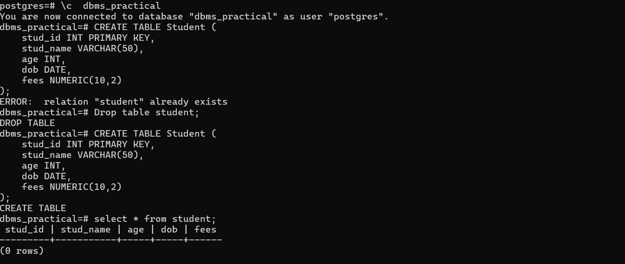

Assignment No 2:-
Q. To create more than one table with referential integrity constraint, PK constraint, Check constraint, Unique constraint, and Not Null constraint.
Code:-
CREATE TABLE Department (
dept_id INT PRIMARY KEY,
dept_name VARCHAR(50) UNIQUE NOT NULL,
location VARCHAR(50)
);

CREATE TABLE Employee (
emp_id INT PRIMARY KEY,
emp_name VARCHAR(50) NOT NULL,
salary NUMERIC(10,2) CHECK (salary > 0),
dept_id INT REFERENCES Department(dept_id)
);
Output:-
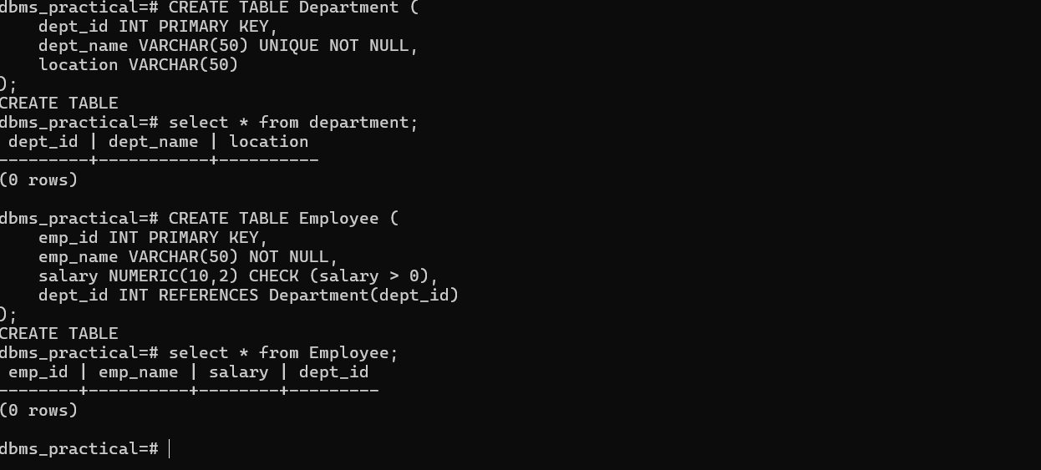

Assignment No:- 3

Q. To drop a table, alter schema of a table, insert / update / delete records using tables created in previous Assignments. (Use simple forms of insert / update / delete statements.)
Code:-
-- Drop a table
DROP TABLE IF EXISTS Temp;

-- Alter Table
ALTER TABLE Employee ADD COLUMN email VARCHAR(50);

-- Insert Records
INSERT INTO Department VALUES (101, 'HR', 'Pune');
INSERT INTO Department VALUES (102, 'IT', 'Mumbai');

INSERT INTO Employee VALUES (1, 'Tanuja', 55000, 101, 'tanuja@gmail.com');
INSERT INTO Employee VALUES (2, 'Megha', 60000, 102, 'megha@gmail.com');

-- Update Record
UPDATE Employee SET salary = 65000 WHERE emp_id = 2;

-- Delete Record
DELETE FROM Employee WHERE emp_id = 1;

Output:-
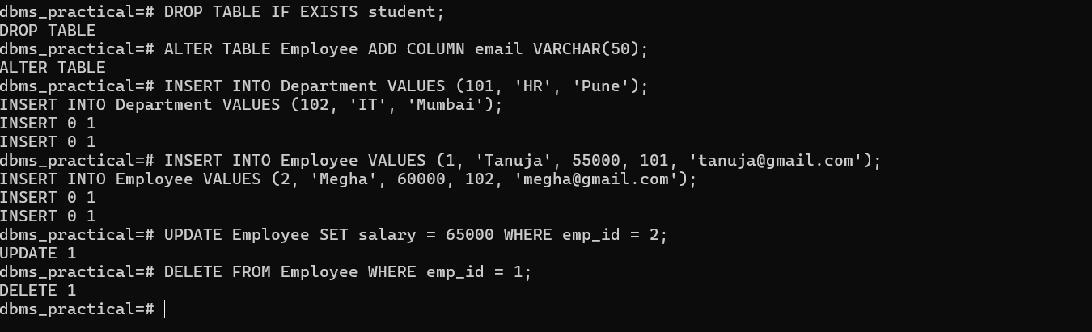

Assignment No:- 4
Q. To query the tables using simple SELECT statements.
SELECT <field-list> FROM table [WHERE <condition> ORDER BY <field list>]
SELECT <field-list, aggregate functions> FROM table [WHERE <condition> GROUP BY <> HAVING <> ORDER BY <>]
Code:-
-- Simple SELECT
SELECT * FROM Employee;

-- Conditional SELECT
SELECT emp_name, salary FROM Employee WHERE salary > 55000 ORDER BY emp_name;

-- Aggregate Functions
SELECT dept_id, COUNT(*) AS total_emp, AVG(salary) AS avg_salary
FROM Employee
GROUP BY dept_id
HAVING COUNT(*) > 0
ORDER BY avg_salary DESC;

Output:-
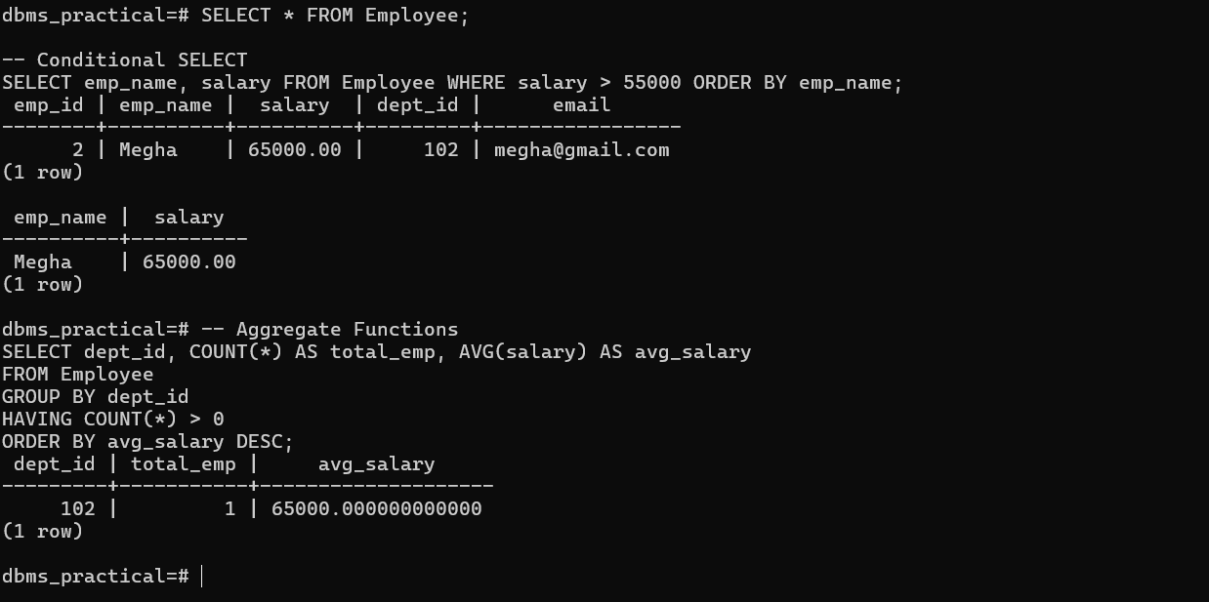

Assignment 5:
Q. To query table using set operations (UNION, INTERSECT).
Code:-
-- Union Example
SELECT emp_name FROM Employee WHERE salary >= 60000
UNION
SELECT emp_name FROM Employee WHERE dept_id = 102;

-- Intersect Example
SELECT emp_name FROM Employee WHERE salary >= 60000
INTERSECT
SELECT emp_name FROM Employee WHERE dept_id = 102;

Output:-
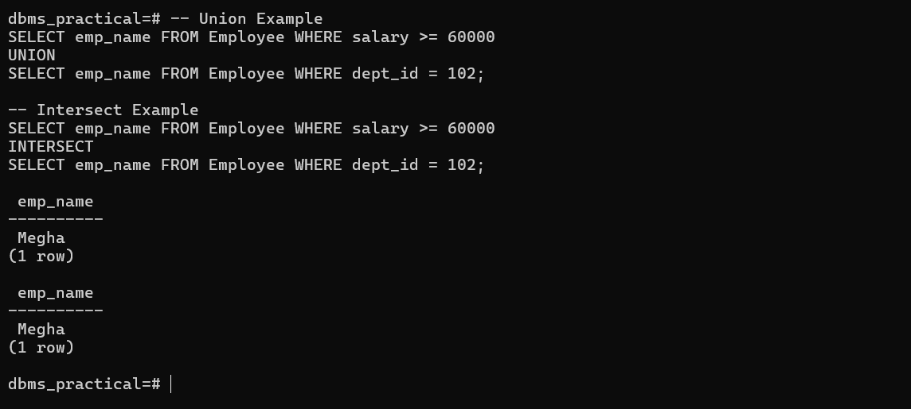

Assignment 6:
Q. To write cursor and trigger, function and stored procedure.
Answer:
-- Cursor Example
DO $$
DECLARE
emp_rec RECORD;
emp_cursor CURSOR FOR SELECT emp_id, emp_name FROM Employee;
BEGIN
FOR emp_rec IN emp_cursor LOOP
RAISE NOTICE 'Employee ID: %, Name: %', emp_rec.emp_id, emp_rec.emp_name;
END LOOP;
END $$;

-- Trigger Example
CREATE OR REPLACE FUNCTION salary_update_func()
RETURNS TRIGGER AS $$
BEGIN
NEW.salary := NEW.salary * 1.1;
RETURN NEW;
END;
$$ LANGUAGE plpgsql;

CREATE TRIGGER salary_before_insert
BEFORE INSERT ON Employee
FOR EACH ROW
EXECUTE FUNCTION salary_update_func();

-- Function Example
CREATE OR REPLACE FUNCTION total_employees()
RETURNS INT AS $$
DECLARE
total INT;
BEGIN
SELECT COUNT(*) INTO total FROM Employee;
RETURN total;
END;
$$ LANGUAGE plpgsql;

-- Stored Procedure Example
CREATE OR REPLACE PROCEDURE raise_salary(IN dep_id INT)
LANGUAGE plpgsql
AS $$
BEGIN
UPDATE Employee SET salary = salary * 1.05 WHERE dept_id = dep_id;
END;
$$;

-- Call Procedure
CALL raise_salary(102);

Output:-
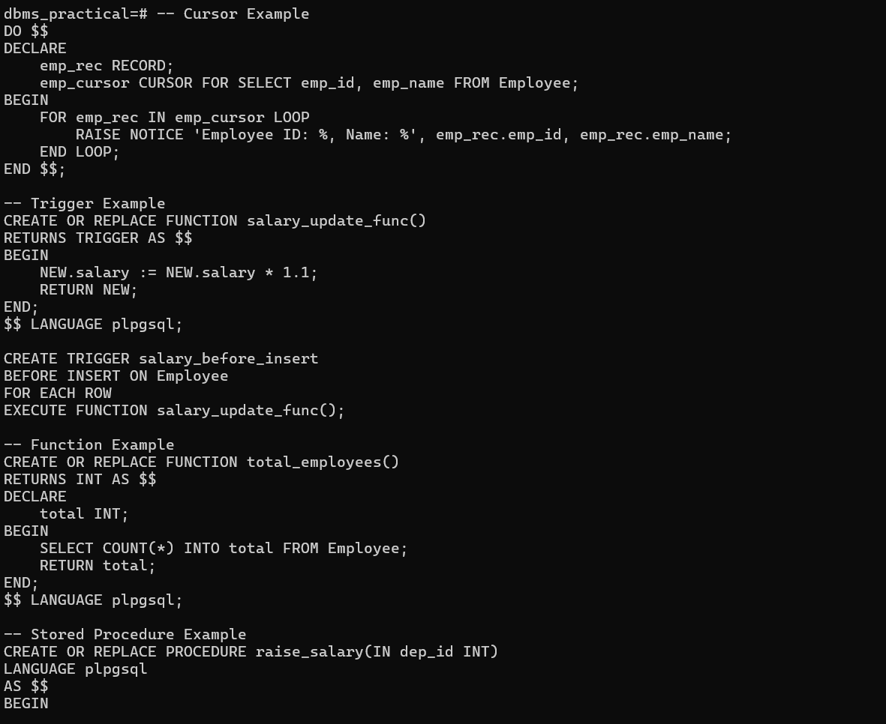

Assignment 7: View Creation
Q. Write SQL statements to create and query a View for employees earning more than 50,000.
Code:
CREATE TABLE Employee (
EmpID SERIAL PRIMARY KEY,
EmpName VARCHAR(50),
Department VARCHAR(30),
Salary INT
);

INSERT INTO Employee (EmpName, Department, Salary) VALUES
('Amit', 'HR', 45000),
('Sneha', 'IT', 60000),
('Rohan', 'Finance', 70000),
('Neha', 'IT', 52000);

-- Create view for high-salary employees
CREATE VIEW HighSalary AS
SELECT EmpName, Department, Salary
FROM Employee
WHERE Salary > 50000;

-- Display view
SELECT * FROM HighSalary;
Output:
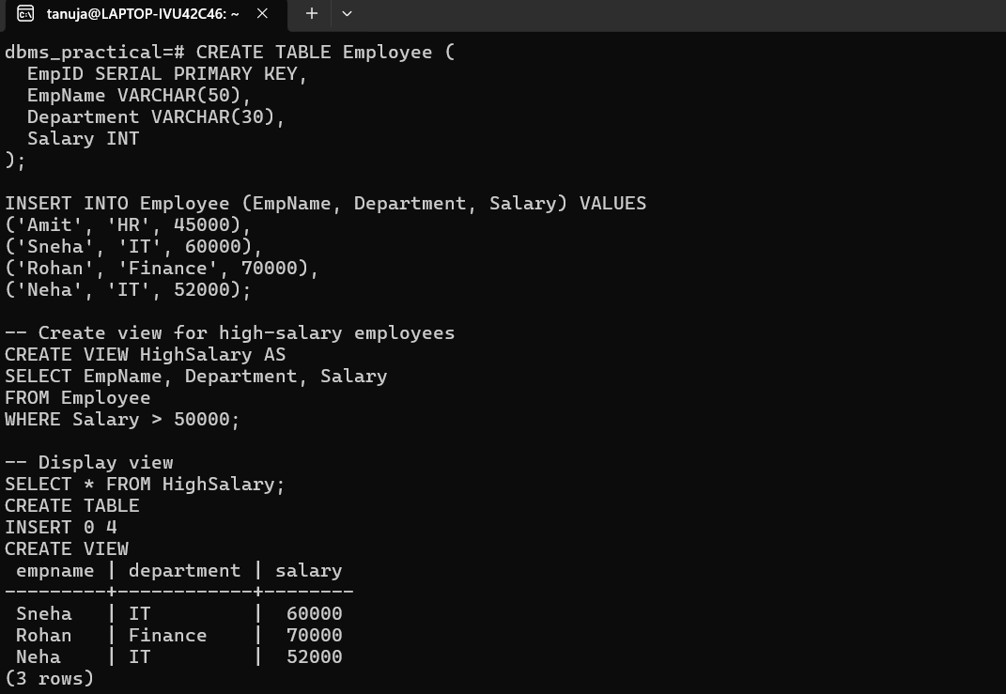

Assignment 8: Joins (Inner Join & Left Join)
Q. Write SQL queries using INNER JOIN and LEFT JOIN on Student and Department tables.
Code:
CREATE TABLE Department (
DeptID INT PRIMARY KEY,
DeptName VARCHAR(30)
);

INSERT INTO Department VALUES
(1, 'Computer'),
(2, 'Mechanical'),
(3, 'Civil');

CREATE TABLE Student (
RollNo INT PRIMARY KEY,
Name VARCHAR(30),
DeptID INT REFERENCES Department(DeptID)
);

INSERT INTO Student VALUES
(101, 'Asha', 1),
(102, 'Ravi', 2),
(103, 'Mira', 1);

-- INNER JOIN
SELECT s.Name, d.DeptName
FROM Student s
INNER JOIN Department d ON s.DeptID = d.DeptID;

-- LEFT JOIN
SELECT s.Name, d.DeptName
FROM Student s
LEFT JOIN Department d ON s.DeptID = d.DeptID;
Output (Inner Join):
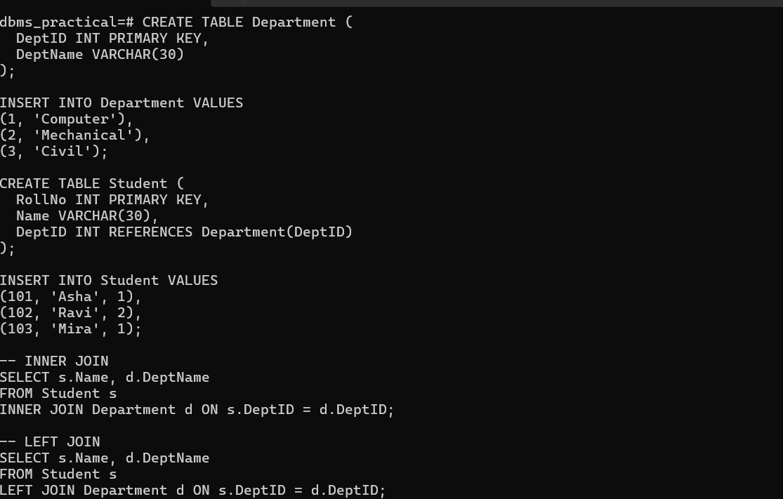
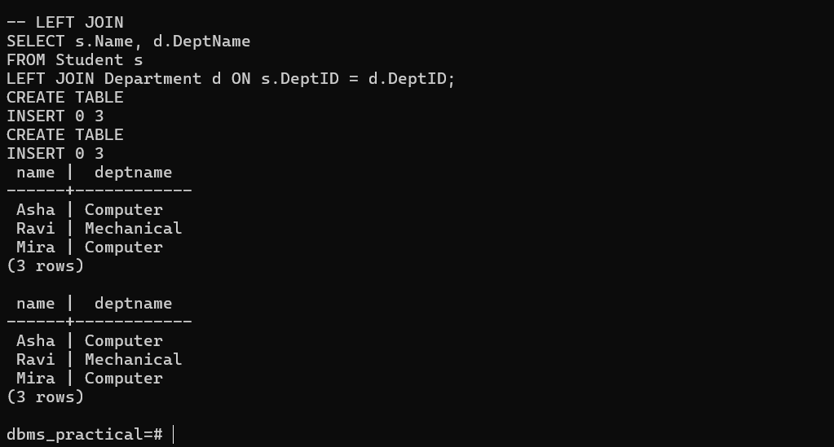

Assignment 9: Aggregate Functions
Q. Write SQL queries using aggregate functions (COUNT, AVG, MAX, MIN, SUM).
Code:
SELECT COUNT(*) AS Total_Employees FROM Employee;
SELECT AVG(Salary) AS Average_Salary FROM Employee;
SELECT MAX(Salary) AS Highest_Salary FROM Employee;
SELECT MIN(Salary) AS Lowest_Salary FROM Employee;
SELECT SUM(Salary) AS Total_Salary FROM Employee;
Output:-
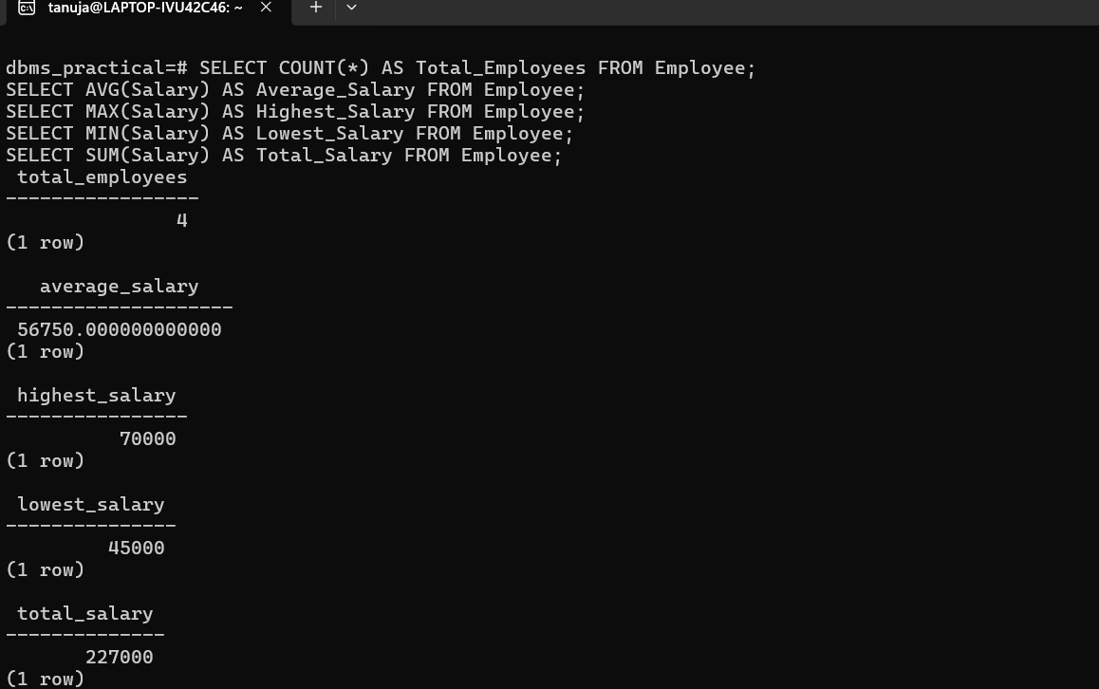
Assignment 10: Subquery
Q. Write an SQL query to display employees who earn more than the average salary.
Code:
SELECT EmpName, Salary
FROM Employee
WHERE Salary > (SELECT AVG(Salary) FROM Employee);
Output:
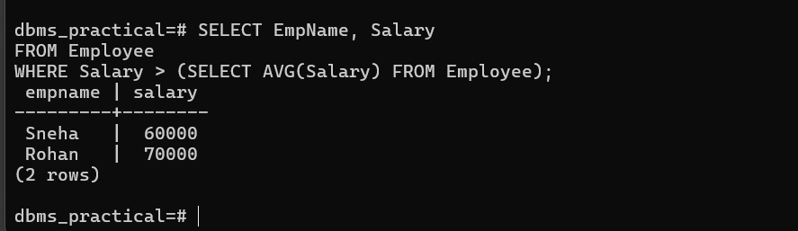

Assignment 11: PL/pgSQL Function
Q. Write a PL/pgSQL function to calculate the square of a number.
Code:
CREATE OR REPLACE FUNCTION square_num(n INT)
RETURNS INT AS $$
BEGIN
RETURN n * n;
END;
$$ LANGUAGE plpgsql;

-- Call the function
SELECT square_num(6) AS Result;

Output:
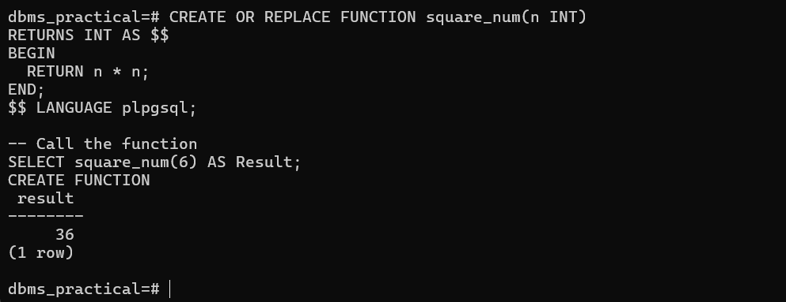

Assignment 12:
Q. To implement scheduling algorithms like FCFS, SJF, and Round Robin.

FCFS (First-Come, First-Served) Scheduling
Code:-
#include <stdio.h>

int main() {
int n, i;
printf("Enter number of processes: ");
scanf("%d", &n);

int bt[n], wt[n], tat[n];
printf("Enter burst times:\n");
for (i = 0; i < n; i++) {
printf("P%d: ", i+1);
scanf("%d", &bt[i]);
}

wt[0] = 0; // waiting time for first process is 0
for (i = 1; i < n; i++) {
wt[i] = wt[i-1] + bt[i-1];
}

for (i = 0; i < n; i++) {
tat[i] = wt[i] + bt[i];
}

printf("\nProcess\tBurst\tWaiting\tTurnaround\n");
for (i = 0; i < n; i++) {
printf("P%d\t%d\t%d\t%d\n", i+1, bt[i], wt[i], tat[i]);
}

return 0;
}
Output:-
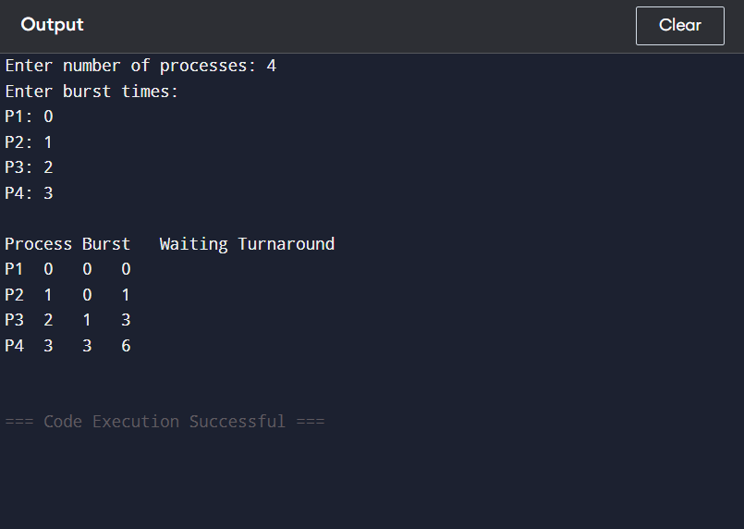

B. SJF (Shortest Job First) Scheduling
Code:-
#include <stdio.h>

int main() {
int n;
printf("Enter number of processes: ");
scanf("%d", &n);

int bt[n], wt[n], tat[n], p[n];
for (int i = 0; i < n; i++) {
printf("Enter burst time for P%d: ", i+1);
scanf("%d", &bt[i]);
p[i] = i+1;
}

// Sort by burst time
for (int i = 0; i < n-1; i++) {
for (int j = i+1; j < n; j++) {
if (bt[i] > bt[j]) {
int temp = bt[i]; bt[i] = bt[j]; bt[j] = temp;
temp = p[i]; p[i] = p[j]; p[j] = temp;
}
}
}

wt[0] = 0;
for (int i = 1; i < n; i++) {
wt[i] = wt[i-1] + bt[i-1];
}

for (int i = 0; i < n; i++) {
tat[i] = wt[i] + bt[i];
}

printf("\nProcess\tBurst\tWaiting\tTurnaround\n");
for (int i = 0; i < n; i++) {
printf("P%d\t%d\t%d\t%d\n", p[i], bt[i], wt[i], tat[i]);
}

return 0;
}

Output:-
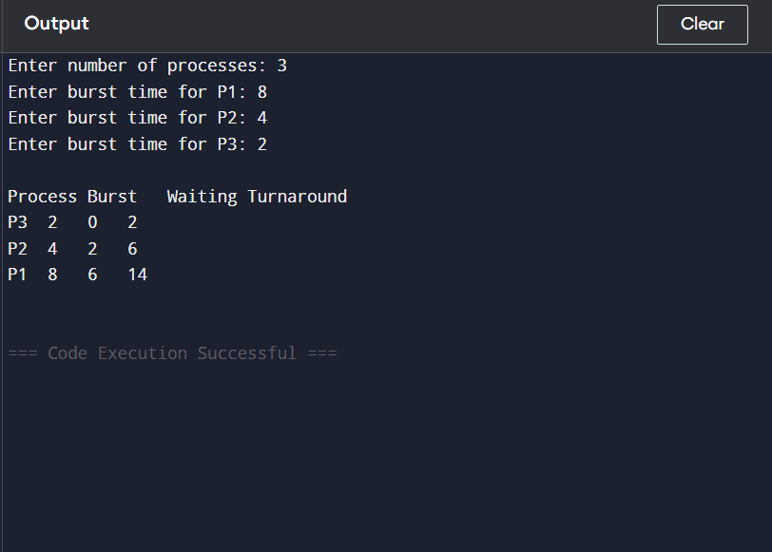

Assignment No 13:- Round Robin Scheduling
Code:-
#include <stdio.h>

int main() {
int n, tq;
printf("Enter number of processes: ");
scanf("%d", &n);

int bt[n], rem_bt[n], wt[n], tat[n];
for (int i = 0; i < n; i++) {
printf("Enter burst time for P%d: ", i+1);
scanf("%d", &bt[i]);
rem_bt[i] = bt[i];
wt[i] = 0;
}

printf("Enter time quantum: ");
scanf("%d", &tq);

int time = 0;
int done;
do {
done = 1;
for (int i = 0; i < n; i++) {
if (rem_bt[i] > 0) {
done = 0;
if (rem_bt[i] > tq) {
time += tq;
rem_bt[i] -= tq;
} else {
time += rem_bt[i];
wt[i] = time - bt[i];
rem_bt[i] = 0;
}
}
}
} while (!done);

for (int i = 0; i < n; i++) {
tat[i] = bt[i] + wt[i];
}

printf("\nProcess\tBurst\tWaiting\tTurnaround\n");
for (int i = 0; i < n; i++) {
printf("P%d\t%d\t%d\t%d\n", i+1, bt[i], wt[i], tat[i]);
}

return 0;
}
Output:-
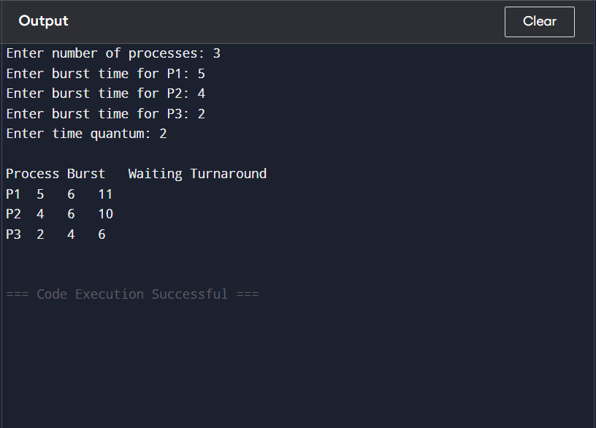

Assignment 14:
Q. To implement Banker’s Algorithm for deadlock avoidance.
Code:-
#include <stdio.h>

int main() {
int n, m, i, j, k;
printf("Enter number of processes: ");
scanf("%d", &n);
printf("Enter number of resources: ");
scanf("%d", &m);

int alloc[n][m], max[n][m], avail[m];
printf("Enter allocation matrix:\n");
for(i=0; i<n; i++)
for(j=0; j<m; j++)
scanf("%d", &alloc[i][j]);

printf("Enter maximum matrix:\n");
for(i=0; i<n; i++)
for(j=0; j<m; j++)
scanf("%d", &max[i][j]);

printf("Enter available resources:\n");
for(i=0; i<m; i++)
scanf("%d", &avail[i]);

int f[n], ans[n], ind = 0;
for(k=0; k<n; k++) f[k] = 0;
int need[n][m];
for(i=0; i<n; i++)
for(j=0; j<m; j++)
need[i][j] = max[i][j] - alloc[i][j];

for(k=0; k<n; k++) {
for(i=0; i<n; i++) {
if(f[i] == 0) {
int flag = 0;
for(j=0; j<m; j++) {
if(need[i][j] > avail[j]) {
flag = 1;
break;
}
}
if(flag == 0) {
ans[ind++] = i;
for(y=0; y<m; y++)
avail[y] += alloc[i][y];
f[i] = 1;
}
}
}
}

int flag = 1;
for(i=0; i<n; i++) {
if(f[i] == 0) {
flag = 0;
printf("System is not in safe state\n");
break;
}
}
if(flag == 1) {
printf("System is in safe state\nSafe sequence is: ");
for(i=0; i<n; i++)
printf("P%d ", ans[i]);
}

return 0;
}

Output:-
